


Thesis Proposal
CONSULTATION SHEET

Project Title:  Addressing Typographic Hallucination in Generative AI Images: An Open-Set Metric Learning Approach to Font Style Recognition | Week # 3 | Group Members:  - Janritch D. Diputado  - Matt Erron G. Cabarrubias
Date:
July 8, 2026

Progress Report (based on the adviser’s previous comments/suggestions) by Students
1st meeting (June 8):
- Find the gaps of the existing system and either optimize or improve on the system.
Recommendations by Adviser
1st meeting (June 8):
- Justify why 50-100 fonts.
- Mention all fonts classified.
- Format as a 1-page file.
- Include General and specific objectives.
- Note that data is classified through Google.
- Justify commonly used fonts and narrow to just English.

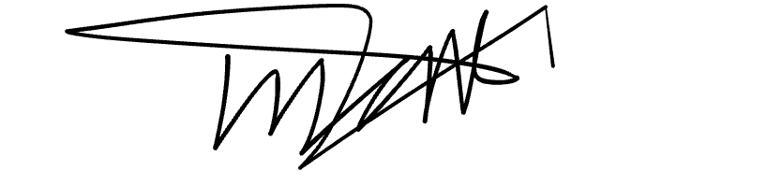
Prepared by:
Janritch D. Diputado | Matt Erron G. Cabarrubias
Noted by:

CHRISTINE D. BANDALAN, MEng
Thesis Adviser

